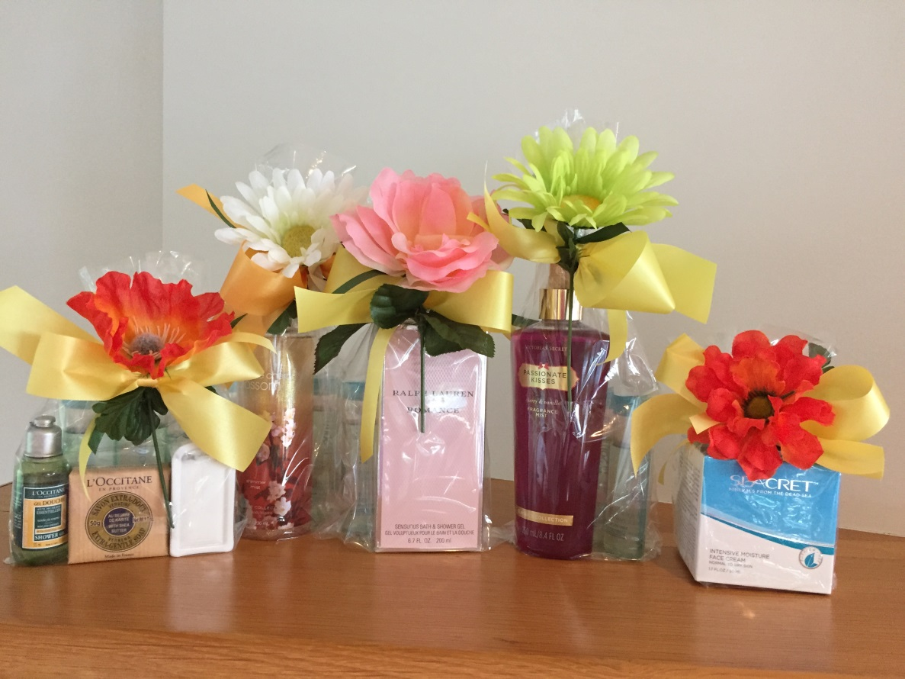

Hawaii Women Lawyers/Hawaii Women’s Legal Foundation
2016 Mother’s Day Project

2009 Public Service Award
National Conference of Women’s Bar Associations

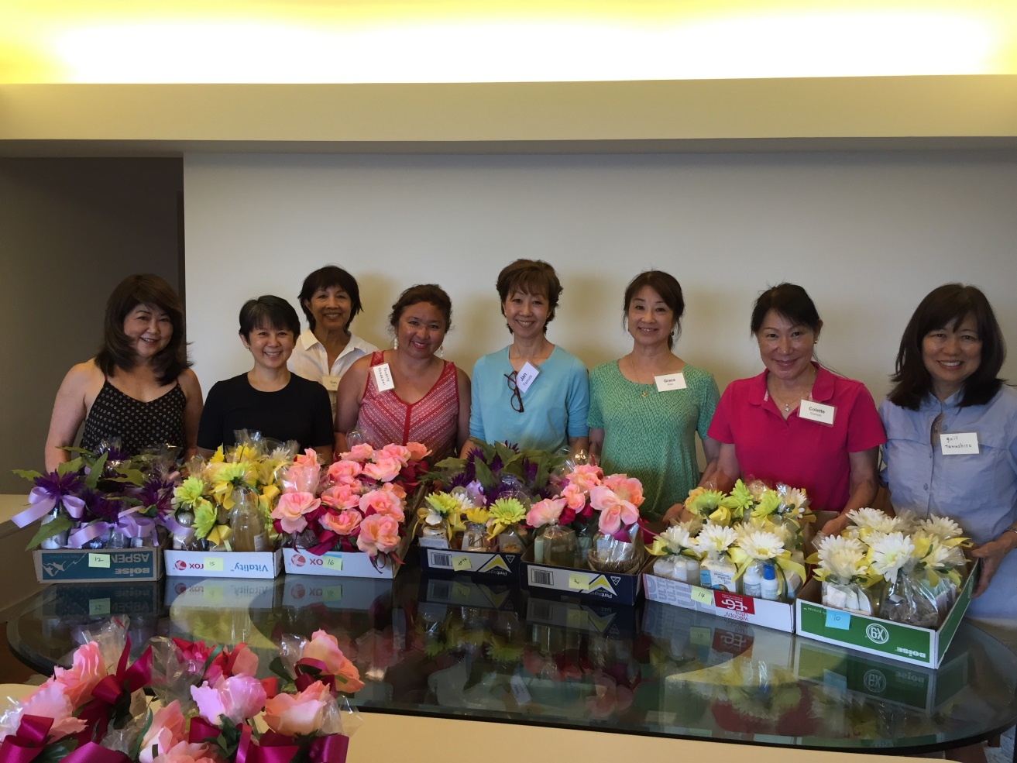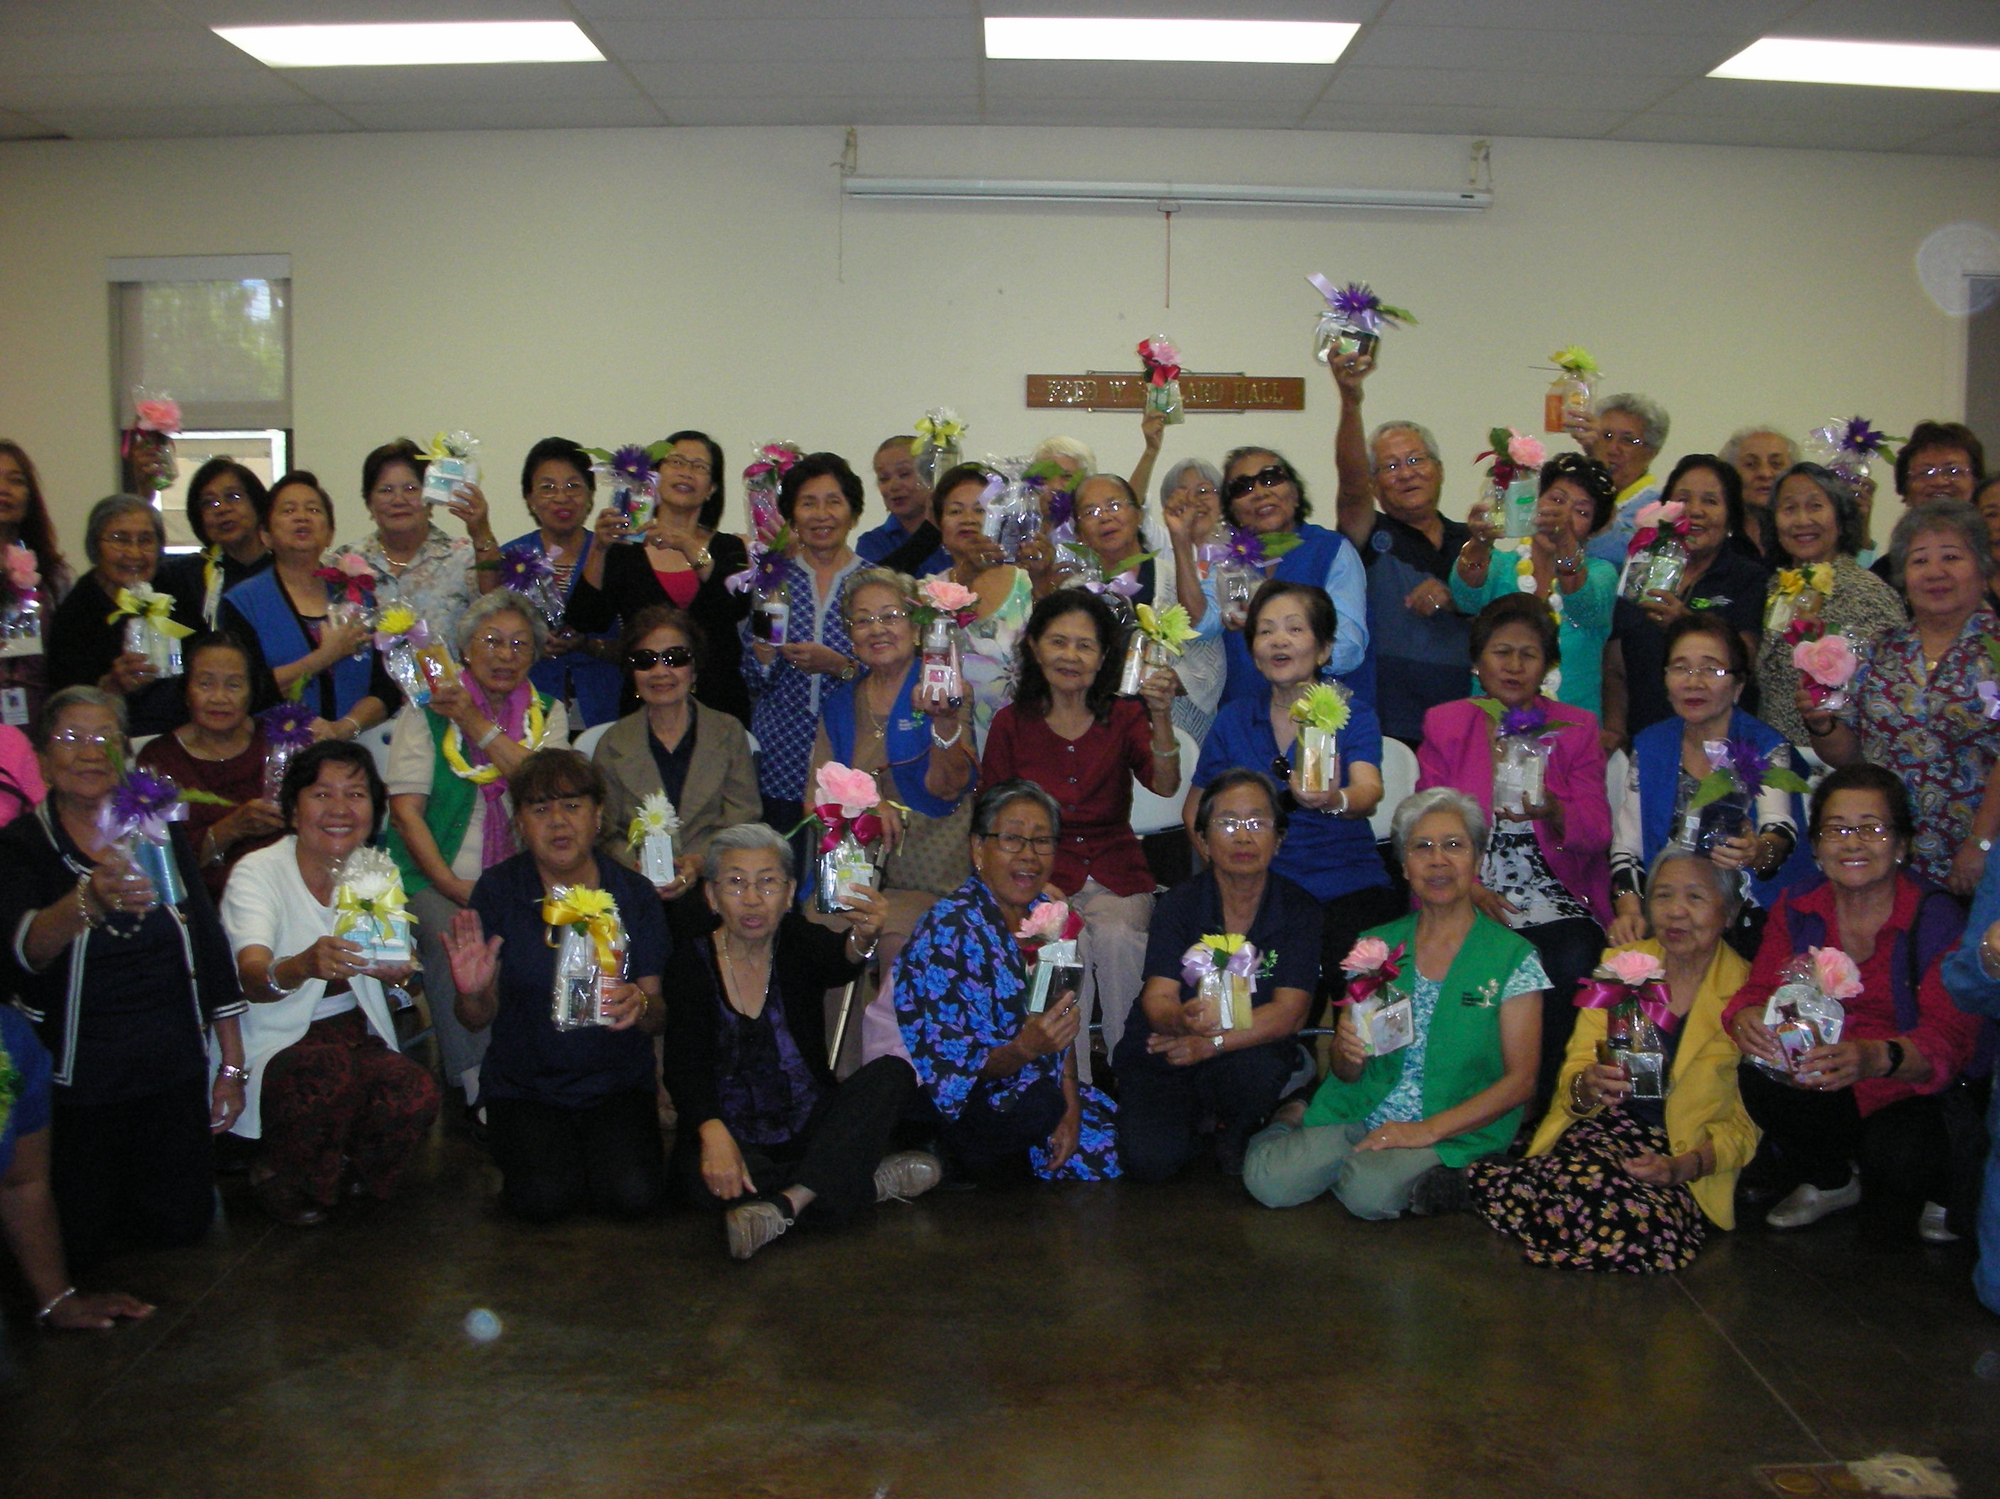
MDP Volunteers Foster Grandparents (Recipients)

Hawaii Women Lawyers (HWL) and Hawaii Women’s Legal Foundation (HWLF) were proud to receive the 2009 Public Service award from the National Conference of Women’s Bar Associations. HWL and HWLF continue their tradition by once again helping hundreds of deserving children say Happy Mother's Day with a pretty gift for a special person.

Please donate:

New, gift-quality cosmetic bags, hand and body lotions, toiletries, and cosmetics

DONATION DROP-OFF LOCATIONS

American Savings Bank Tower, Alston Hunt Floyd & Ing, 1001 Bishop Street, 18th Floor, Cori Lau
Cades Schutte Building, Cades Schutte LLLP, 1000 Bishop Street, 12th Floor, Rhonda Griswold
First Hawaiian Center, Ashford & Wriston, LLLP, 999 Bishop Street, 14th Floor, Lynne McGivern
Hawaii Opera Theatre, Hawaii Opera Plaza, 848 Beretania Street, Suite 301, Tracy Jefferson
Pacific Guardian Center – Mauka Tower, Rush Moore LLP, 737 Bishop St., Suite 2400, Irene Anzai
UH Richardson Law School Student Services Office, 2515 Dole Street; Ramona Hussy

DEADLINE – Friday, February 26, 2016

